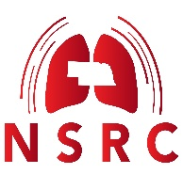
Respiratory Education Research / Quality Improvement Poster
Scope and Objectives
- To support the advancement of respiratory therapy by promoting high-quality clinical outcomes, patient safety, quality improvement initiatives, education, health policy, healthcare business practices, wellness, and other relevant topics.
- To foster scholarly activity within the respiratory care community and increase visibility for professional contributions.
- To encourage research and dissemination of findings that contribute to evidence-based recommendations for the enhancement of respiratory therapy practices.
Register via email for the poster presentation submitting the following information:
  - Name(s) of presenter(s) & AARC member number(s).
  - Address
  - Email & phone number
  - School / Hospital
  - RC program director/ Hospital Director
  - Presentation topic
  - In the subject field of the email should read: “NSRC-Poster Presentation-presenter name(s) – year”

What are the poster requirements?

Poster Format – Participants are encouraged to use the following guidelines:
- PPT Template: SEE ATTACHMENT

Project Abstract – Participants are encouraged to use the following guidelines:
- Abstract Template: SEE ATTACHMENT
- Printed text recommendation: 800 – 1200 words (1500 words, maximum suggested).
- Avoid excessive text, using approximately 1/3 text, 1/3 figure(s) and 1/3 blank space.
- Poster materials and text should be viewable at approximately 5-7 feet away.
- Avoid using “ALL UPPER CASE”.
- Consider using italics, bold face or underline (but not all 3 at the same time).
- Use “Left Alignment” and some information presented in “bullet form” if desired.
- Consider those who may be color blind (inability to tell green from red).
- Follow AMA Guidelines for citations and references: http://www.scribd.com/doc/42208013/Manuscript-Preparation-Guide.

Conference Presentation
- The Participants will present the Poster Format-PPT for three minutes and answer questions for two minutes.
- Conference Incentive
Authors whose posters are selected for presentation at the annual state conference will receive a discounted registration rate for the event.
How will the posters be judged?
- See the NSRC Rubric
When is the application deadline?
- Application deadline for the poster material is January 15th 2026. The email must be received by midnight.

Attachment 1
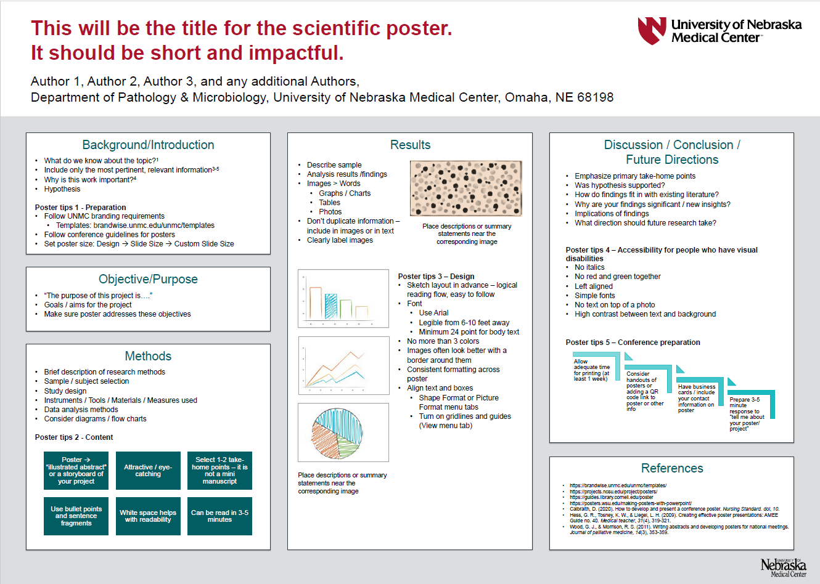

Attachment 2
ABSTRACT INFORMATION 2026

Title: “Insert Title”

Resident: Name and Degree

Mentor: Faculty/Staff name(s) and title(s)

Background: (insert paragraph)

Objective: (insert paragraph)

Methods: (insert paragraph)

Results: (insert paragraph)

Conclusions: (insert paragraph)

